ADMINISTRATOR TRAINING GUIDE
Estimate Cases and AI Analysis
How an estimate workspace is created, analyzed, costed, reviewed, and prepared for production output
Purpose: Explain the Estimate Cases pages and the background AI process in simple terms, while clearly identifying production outputs that are still being designed.

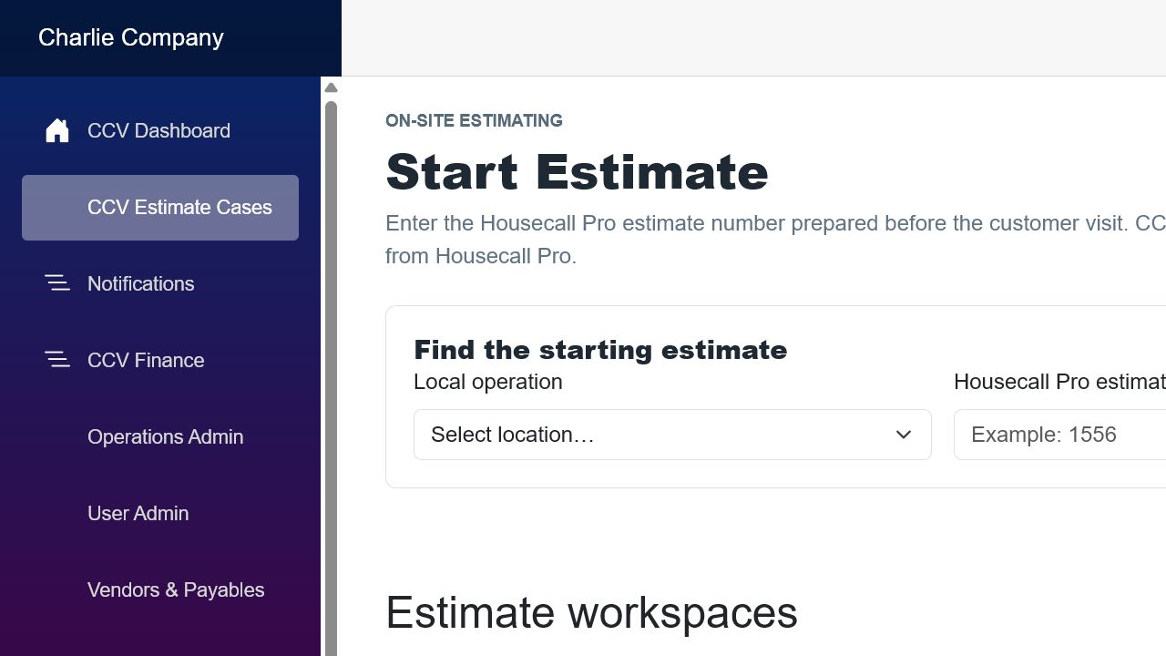
Screen example: start an estimate by retrieving its Housecall Pro estimate, or reopen an existing CCV workspace.

1. What an Estimate Case is
An Estimate Case is CCV’s working copy of an on-site estimate. Housecall Pro remains the source for the starting customer and estimate information. CCV adds project notes, task sections, photographs, AI analysis, costing rules, and an audit history.
Current behavior: The application can start from a Housecall Pro estimate, maintain collapsible project tasks, submit task-specific CentCom analysis, organize materials by supplier, resolve catalog fallbacks, calculate internal job cost and margin automatically, apply an estimate-level promotional discount and tax rate, and save pricing with the estimate.

Important boundary: The AI result is a recommendation for review. It should not automatically become a supplier order or customer contract.

2. Starting or reopening an Estimate Case
Page area | What the administrator does | What CCV does
Housecall Pro estimate number | Enter the HCP estimate number and retrieve it. | Finds the starting estimate and customer/project information.
Create workspace | Confirm the correct estimate and create the workspace. | Stores a CCV case linked to the HCP estimate.
Existing workspaces | Select a workspace already in progress. | Reopens saved notes, tasks, photographs, analysis revisions, and pricing.
Delete workspace | Use only when the workspace should be permanently removed. | Deletes the CCV workspace after a confirmation prompt; it does not delete HCP’s estimate.

Before creating: Verify the customer and property address. Do not create a second workspace for the same HCP estimate unless there is a deliberate business reason.

3. The Estimate Workspace
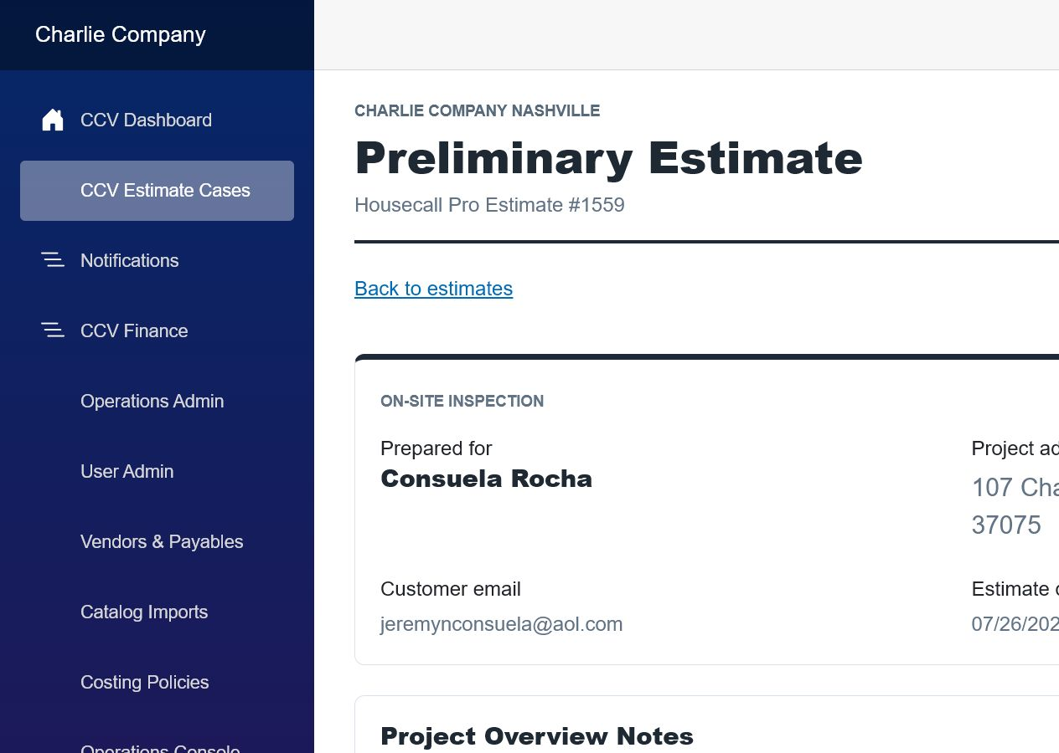
Screen example: the estimate header, customer information, and Project Overview Notes.

Customer and project information
- Customer name, address, contact information, estimate number, and estimate date originate from Housecall Pro.
- The Project Overview Notes describe the entire project, site conditions, goals, and constraints.
- The microphone button can dictate notes when the browser and device permit microphone access.

Project tasks
A case can contain any number of project tasks. Each task represents a distinct piece of work that CentCom can analyze separately.
Task feature | Plain-language purpose | Example
Task number and type | Identifies the work and its order. | Project Task 1 - Deck; Project Task 2 - Roof Structure.
Scope of Work | Estimator’s description of what must be done. | Remove two decks and rebuild with pressure-treated lumber.
Photo template | Requests the views and measurements needed for that task type. | Overall view, length, width, endpoints, stairs, and structural conditions.
Additional photos | Allows useful images beyond the required template. | Access constraints, damage, or unusual framing.
Save Project Task | Stores the current notes and photographs. | Save before leaving the page or starting analysis.
Delete Task | Removes a task after confirmation. | Use when the task was added by mistake.

Good practice: Use one task for each separately costed scope. Clear task boundaries produce clearer material lists, crew assumptions, and margins.

4. CentCom Analysis on the workspace
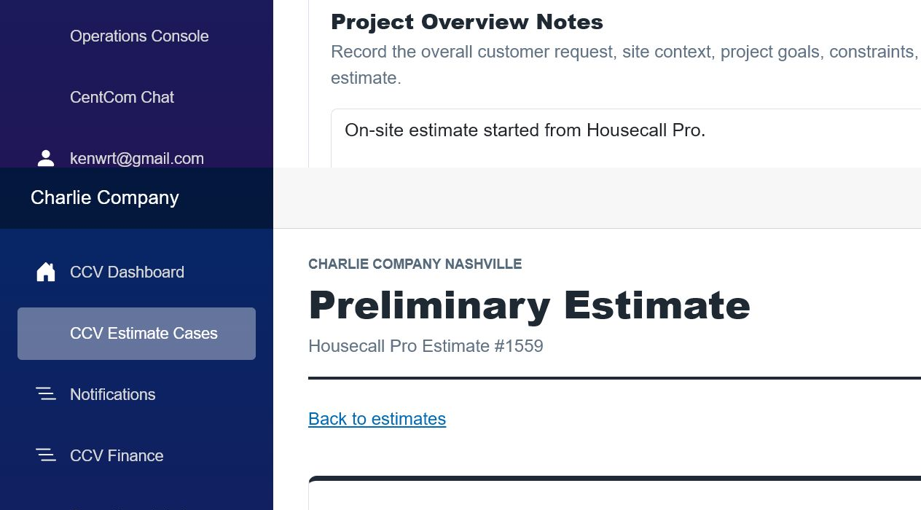
Screen example: the project task and its CentCom analysis area.
- Analyze submits the task’s current saved notes and photographs.
- Queued means the request is waiting for background processing.
- Reanalyze creates a new analysis revision; it does not erase the earlier audit trail.
- Unresolved means CentCom recommended a material that CCV could not safely match to the local catalog or to an exact Home Depot result. The original requested description remains visible so the estimator can replace it, price it once, add it manually, or add an approved item to the catalog.
- Excluded means a policy intentionally prevented an AI suggestion from entering material cost.
Review required: Unmatched items, missing prices, uncertain quantities, exclusions without recovery, and unexpected task durations must be resolved before approval.

5. Pricing and audit information
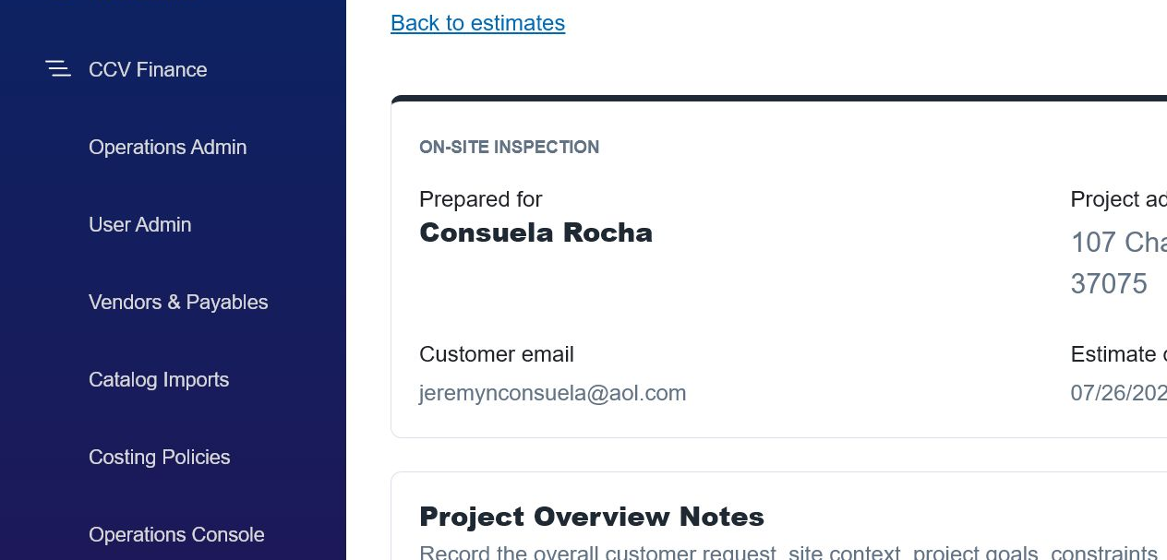
Screen example: job cost summary and provisional pricing information.
The pricing area combines the latest task material analysis with the active costing-policy snapshot. Internal Estimating shows current job cost, editable desired gross margin, and selling price before discount. Customer Price separately shows the whole-job promotional discount, manually entered tax rate, calculated tax, customer total, and effective gross margin. Values recalculate automatically and save with Save Estimate.
Cost layer | Typical contents | Source
Materials | Catalog-matched lumber, fasteners, hardware, finishes, and supplies. | CentCom recommendation + vendor catalog + standard supply kits.
Labor | Crew days multiplied by the matching daily crew rate. | Task type/work type crew rate card.
Task/project costs | Disposal, permits, delivery, rental, mobilization, or management. | Additional cost rules.
Overhead | Allocated operating cost and any approved additional overhead. | Active costing policy.
Contingency | Allowance for normal estimating uncertainty. | Policy percentage.
Suggested price | Cost converted to price using the applicable margin. | Task margin rule or policy fallback.

6. What happens in the background when AI analyzes a task
Simple description: CCV takes a frozen copy of the task, asks CentCom for a structured recommendation, checks that recommendation against approved business data, calculates costs, and saves a new auditable revision.

1. Submission
The user saves the task and clicks Analyze or Reanalyze.

2. Input snapshot
CCV records the task type, work type, notes, photographs, customer/project context, user, time, and revision number.

3. Queue
A background job is created with Queued status so the web page does not need to remain open.

4. Worker claims the job
A background service selects the queued job and marks it Processing. Duplicate workers must not process the same revision.

5. Validation
The worker checks CentCom configuration, usable scope notes, photo references, operation access, and required identifiers.

6. Business context
CCV loads relevant vendor catalog pricing, standard supply kits, crew rates, margin rules, additional costs, overhead policy, and material exclusions.

7. CentCom request
CCV sends a task-specific instruction asking for structured materials, quantities, assumptions, estimated project days, confidence, and warnings.

8. Response validation
CCV verifies the response format and rejects incomplete or unsafe output instead of silently guessing.

9. Material normalization
Descriptions, units, quantities, waste, and categories are normalized for matching.

10. Catalog matching
Each recommended material is matched first against active local vendor catalogs. When there is no local match, the Home Depot lookup can return an exact or similar candidate. Exact approved products can be added to the local Home Depot catalog. Similar and unresolved candidates remain clearly identified for human review.

11. Exclusions and kits
Policy exclusions prevent duplicate or inappropriate suggestions; required standard kits are added automatically.

12. Cost calculation
CCV calculates materials, labor, task/project costs, overhead, contingency, and margin using the applicable policy revision.

13. Save revision
The raw technical response, normalized recommendations, matches, exclusions, assumptions, costs, errors, and timestamps are saved.

14. Finish or fail
The job becomes Completed, Needs Review, or Failed. A failed revision retains a readable reason and can be retried.

7. What should be visible in the operations console
Event | Minimum information | Why it matters
Queued | Time, operation, estimate, task, revision, requesting user. | Shows that the request was accepted.
Processing | Worker/service, model, start time, correlation ID. | Shows where the job is running.
Completed | Duration, material count, matched/unmatched count, cost totals, warnings. | Shows success and review needs.
Needs Review | Missing prices, low confidence, exclusions, or questionable quantities. | Routes work to an administrator.
Failed | Module, readable error, technical details, retry count, next action. | Makes failures diagnosable.

Consolidated logging: When UI and APIs run on different machines, every service should write events using the same estimate ID, task ID, revision, operation, and correlation ID. CCV can then display one chronological timeline.

8. Proposed production outputs - not finalized
Design status: The following outputs are recommended next steps, not a statement that they are fully implemented. Business approval, security decisions, supplier preferences, and legal review are still required.

A. Supplier material list or request for pricing
- Generate one supplier-specific list from approved, catalog-matched items.
- Include estimate/job reference, delivery location, quantities, units, requested delivery date, and special instructions.
- Do not include the customer’s selling price, margin, internal overhead, or unrelated personal information.
- Require an administrator to review and approve the email before it is sent, at least during the initial rollout.
Recommended trigger: Estimate analysis approved and material selections locked - not merely when AI processing completes.

B. Internal cost analysis for dashboards
- Display material, labor, task costs, overhead, contingency, total cost, suggested price, and margin.
- Show the exact analysis and policy revisions used.
- Show unmatched items, missing prices, low-confidence recommendations, and overrides.
- Allow drill-down from group to local operation, estimate, task, and individual cost line.
Audience: Administrators and authorized local operators. Internal costs and margins should never appear on a customer-facing page.

C. Customer-facing polished estimate
- Customer and property information, project overview, task-by-task scope, selections, and pricing.
- Clear inclusions, exclusions, allowances, change-order rules, payment schedule, expiration date, and signature/acceptance.
- Approved photographs or diagrams only when they help explain the work.
- No raw AI response, confidence score, vendor cost, internal labor cost, overhead, or margin.
Legal gate: Customer terms and legal language must be approved by qualified counsel for each operating jurisdiction. AI may assemble approved clauses, but it should not invent legal terms.

Send gate: The customer document should require estimator or manager approval before email delivery. Analysis completion alone should never send it.

9. Recommended notifications
Notification | Primary recipient | Suggested channel | Approval needed?
Analysis queued | Requesting user | In-app status | No
Analysis completed - clean | Requesting user | In-app; optional email | No
Analysis needs review | Estimator + assigned administrator | In-app + email | No
Analysis failed | Administrator/operations console | In-app + email | No
Supplier list ready | Estimator or purchasing approver | In-app | Yes, before supplier email
Supplier email sent | Purchasing + audit log | In-app; copy by policy | Recorded approval
Customer estimate ready | Estimator/manager | In-app + email | Yes, before customer send
Customer estimate sent | Estimator + audit log | In-app; delivery tracking | Recorded approval

Noise control: Use email for action-required or failed events. Routine progress should remain in the application. SMS should be reserved for truly urgent, opt-in events.

10. Decisions still needed before production output
- ☐ Who can approve an AI analysis, supplier request, and customer estimate?
- ☐ Which unmatched-item or confidence thresholds require review?
- ☐ Which suppliers accept email lists, CSV attachments, PDFs, or API orders?
- ☐ Should supplier communication be a price request, purchase order, or delivery request?
- ☐ What cost and margin details can local operators see?
- ☐ Which legal clause library applies to each state and local operation?
- ☐ What customer document numbering, expiration, deposit, and signature rules are required?
- ☐ Which events use in-app notification, email, SMS, or no notification?
- ☐ How long are raw AI responses, photos, approvals, and delivery records retained?
- ☐ What is the rollback process when catalog prices or policy assumptions are wrong?

Administrator test checklist
- ☐ Retrieve the correct Housecall Pro estimate and verify the customer and property.
- ☐ Enter project overview notes and create clearly separated tasks.
- ☐ Save notes and required photographs before analysis.
- ☐ Confirm the analysis progresses from Queued to a final status.
- ☐ Review each supplier group, material quantity, match type, original requested description, price source, and review decision.
- ☐ Resolve every similar, unresolved, removed, or unpriced material by accepting, replacing, manually adding, cataloging, or approving it as a one-off item.
- ☐ Verify the correct crew rate, policy revision, overhead, contingency, and margin.
- ☐ Confirm Reanalyze creates a new revision and preserves the earlier audit.
- ☐ Do not send supplier or customer output until the applicable approval workflow exists.
Final principle: AI prepares a recommendation. CCV validates and costs it. An authorized person approves what leaves the company.

11. Current Estimate Review, Catalog Fallback, and Pricing Workflow
This section documents the current Estimate Workspace behavior added after the original guide was issued. It describes what the estimator sees, which decisions remain manual, and what is saved when the estimate is updated.
Revision scope: Current as of July 31, 2026. The workflow is designed for estimator review: AI proposes and organizes materials, but an authorized person controls catalog additions, one-off pricing, margin, discount, tax, and the final saved estimate.

Workspace organization
- Project Tasks is collapsible and contains the task selector, Add Project Task action, and every individual project task.
- Each project task is independently collapsible and retains its work type, scope, job-day assumptions, overrides, photographs, and CentCom revisions.
- CentCom Analysis is collapsible inside its task. Supplier groups such as Home Depot, Decks & Docks, and Unresolved materials are also independently collapsible.
- Collapsing a section only changes the screen view; it does not delete or reject any saved information.
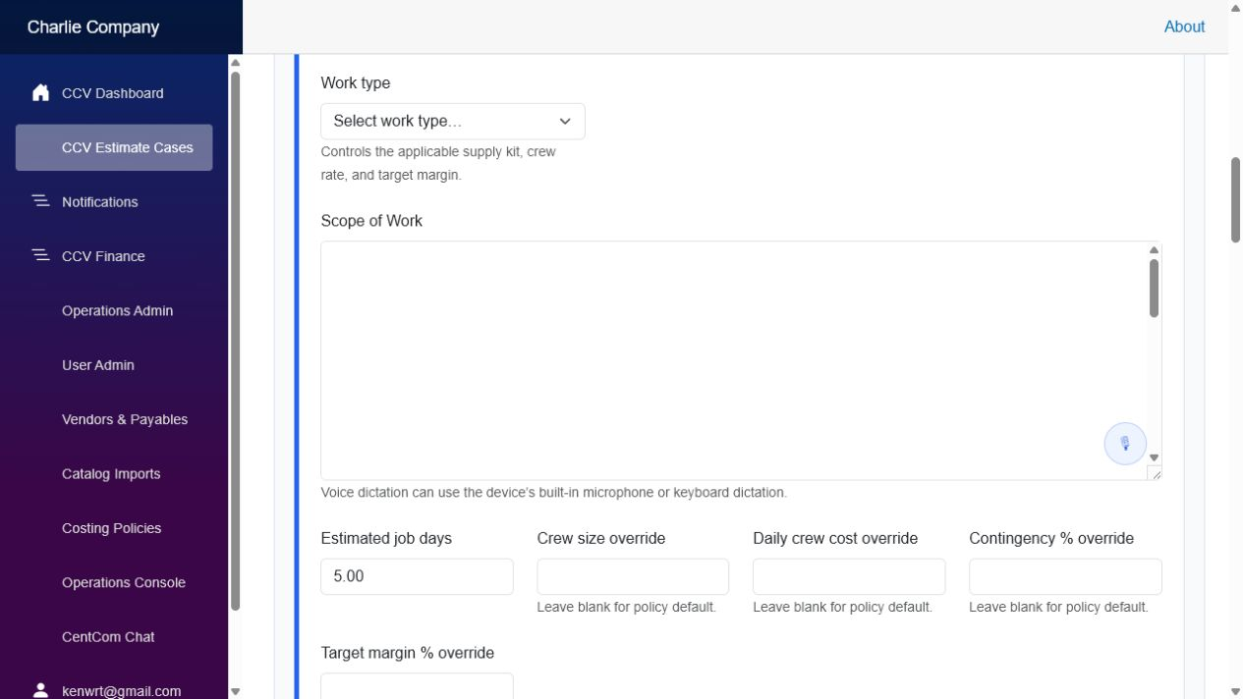
Figure 5. Expanded project task with scope, work-type controls, job-day assumptions, and policy overrides.

CentCom analysis and review status
- Analyze uses the currently saved task description and photographs. Reanalyze creates a new revision while preserving prior analysis history.
- The revision header shows submission time, model, assumptions, and questions or warnings that require estimator judgment.
- Needs Review indicates that one or more materials or assumptions require a decision before the analysis can be treated as finalized.
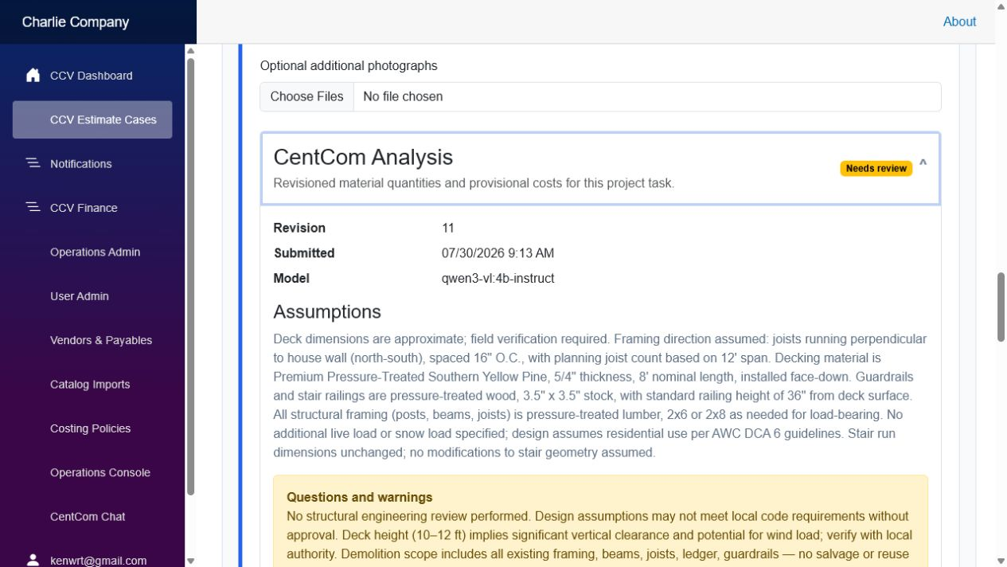
Figure 6. Expanded CentCom Analysis showing revision metadata, assumptions, warnings, and review status.

Vendor grouping and catalog fallback decisions
- Material recommendations are grouped by supplier so the estimator can review one vendor subtotal at a time.
- Local vendor catalogs are checked first. When no local catalog match exists, the Home Depot lookup may return an exact or similar generalized inventory match.
- An exact Home Depot product may be accepted and added to the local Home Depot catalog after review.
- A similar product is visibly labeled and must remain a conscious estimator choice; it is never silently treated as the originally requested material.
- For unresolved materials, CCV keeps the original description visible. The estimator may replace from the catalog, enter a manual item and price, save an approved item to the catalog, use it once without cataloging, or remove it from the estimate.
- The supplier subtotal and overall material subtotal update from the active material decisions. Reanalyze remains available at the bottom of the analysis.
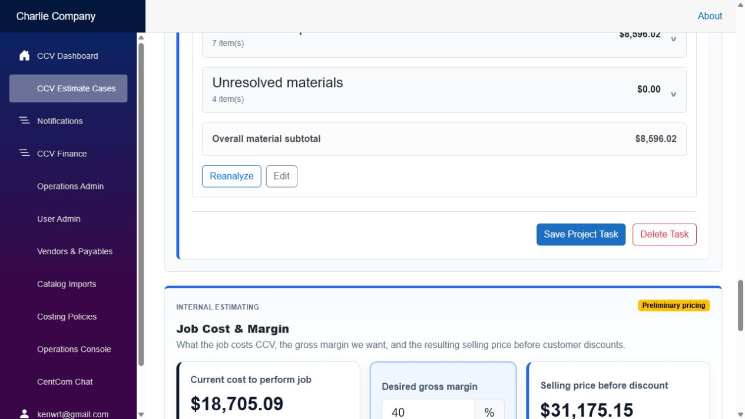
Figure 7. Supplier and unresolved-material groups, overall material subtotal, review actions, and the beginning of Internal Estimating.

Internal Estimating
- Current cost to perform job combines materials, labor, standard supplies, overhead, contingency, and other applicable costing rules.
- Desired gross margin is editable as a whole-number percentage. The selling price before discount recalculates automatically as cost or margin changes.
- Task-level cost breakdown remains available for internal review. Preliminary pricing is clearly identified until the underlying material analysis is finalized.

Customer Price
- Promotional Discounts is a whole-number percentage applied across the job as a whole.
- Tax rate is entered manually during estimating, supports two decimal places, and is associated with the displayed customer service address.
- Price before discount, discount amount, discounted subtotal, tax, customer total, and effective gross margin update automatically while the estimator edits the controls.
- A pricing note documents the reason for a promotional discount or job-level margin change.
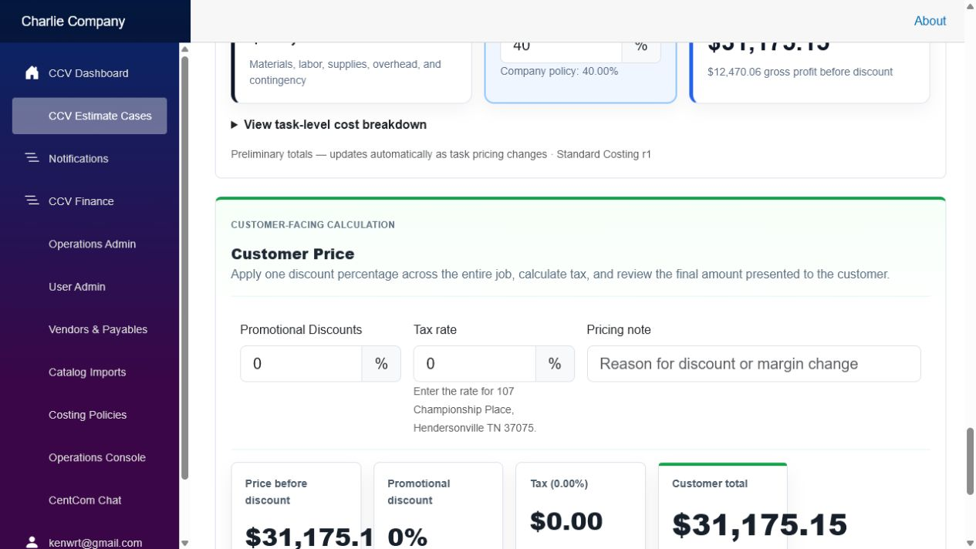
Figure 8. Customer-facing calculation with promotional discount, editable tax rate, pricing note, tax amount, and customer total.

Saving and review controls
- Save Project Task stores the task-specific scope, assumptions, overrides, and photo references.
- Material review actions are performed on individual items; the former analysis-level Accept and Reject buttons are no longer displayed.
- There is no separate Save Pricing action. Save Estimate is the single save point for estimate overview, task details, margin, promotional discount, tax rate, pricing note, and calculated customer total.
- Reanalyze remains separate from saving. It creates a new AI analysis revision and should be used after meaningful scope or material-input changes.
Estimator responsibility: Verify customer and property information, material suitability, quantities, supplier selection, tax treatment, margin, discount, and final customer total before relying on the estimate. Similar matches and AI recommendations require human review.

Updated administrator test checklist
- ☐ Open and close Project Tasks, an individual task, CentCom Analysis, and each supplier group.
- ☐ Confirm supplier subtotals and the overall material subtotal reflect active material decisions.
- ☐ Exercise Accept item, Remove, Replace from catalog, manual item entry, Save to Home Depot catalog, and Use price once where applicable.
- ☐ Confirm the original requested description remains visible for similar or unresolved products.
- ☐ Change desired gross margin and confirm selling price updates without a Calculate button.
- ☐ Enter a whole-number promotional discount and a two-decimal tax rate; confirm the customer total and effective margin update.
- ☐ Save the estimate, reopen it, and verify margin, discount, tax, pricing note, and calculated totals persist.
- ☐ Reanalyze a changed task and confirm a new revision is created without deleting the prior audit history.

